`Lucrarea 8 TS

LOCUL RĂDĂCINILOR SI DESCRIEREA ÎN SPAłIUL STĂRILOR
A SISTEMELOR CONTINUE

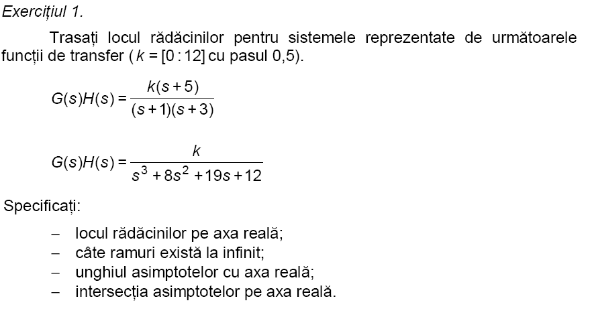
REZOLVARE:
k1=[0:0.5:12];
num1=[1 5];
den1=[1 4 3];
%rlocus(num1,den1,k1);
% locul radacinilor este (-∞,-5) (-1,-3)
% avem 1 ramura la infinit
unghiul asimptotelor cu axa reală: 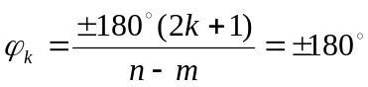;n=2,m=1;k=0;
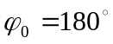
Intersectia cu axa reala 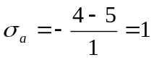-abcisa punctului de intersecţie
k2=[0:0.5:12];
num2=[1];
den2=[1 8 19 12];
rlocus(num2,den2,k2)

Concluzii:
%locul radacinilo (-∞,-4) (-3,-1),
%avem 1 ramuria la infinit

Unghiul asimptotelor cu axa reala
;n=3,m=0;k=0,1,2;
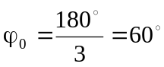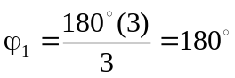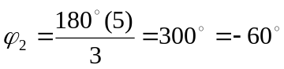

Intersectia cu axa reala 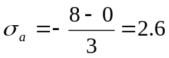-abcisa punctului de intersecieţ
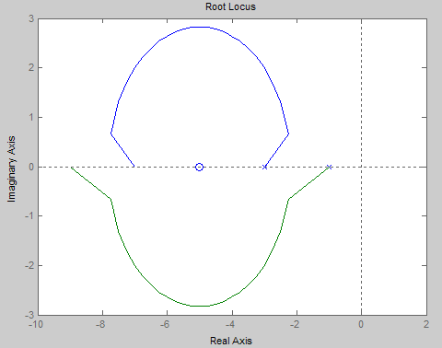
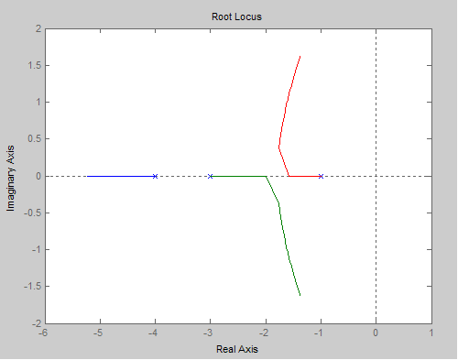
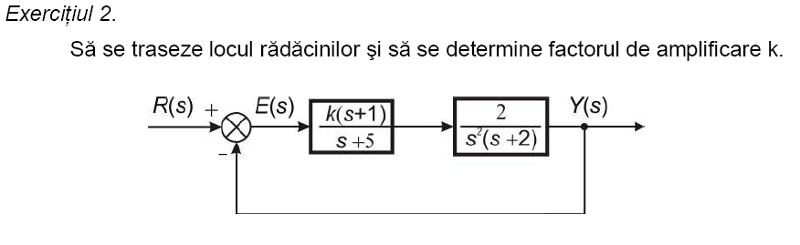
REZOLVARE:
num=[2 2];
den=[1 7 10 0 0];
[r,k]=rlocus(num,den)
rlocus(num,den)
Concluzii:
%locul radacinilo (-4,-∞) ;(0,-2)
%avem 3 ramuri la infinit

k =1.0e+007 *
Columns 1 through 9
0 0.0000 0.0000 0.0000 0.0000 0.0000 0.0000 0.0000 0.0000
Columns 10 through 18
0.0000 0.0000 0.0000 0.0000 0.0000 0.0000 0.0002 2.0294 Inf
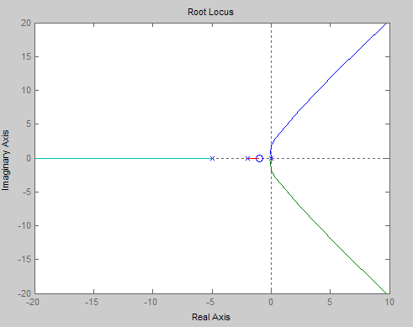

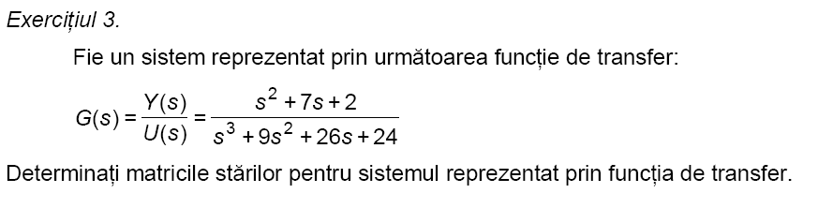
REZOLVARE:
num=[1 7 2];
den=[1 9 26 24];
[A,B,C,D]=tf2ss(num,den)

Concluzii:
%sistemul are 1 intrare (B are o coloana) si 1 iesire (C are o linie)

A = -9 -26 -24
1 0 0
0 1 0
B = 1
0
0
C = 1 7 2
D = 0
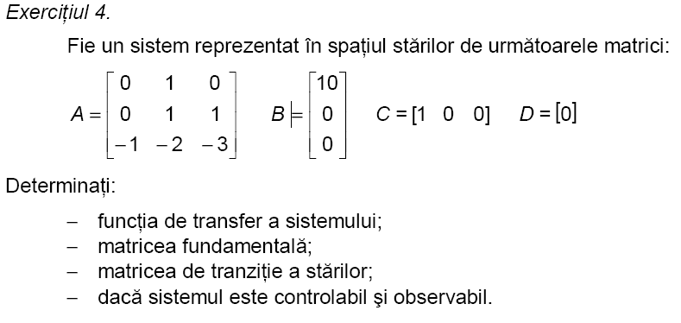

REZOLVARE:
A=[0 1 0;0 1 1;-1 -2 -3];
B=[10;0;0];
C=[1 0 0];
D=[0];
[num,den]=ss2tf(A,B,C,D,1)
tf(num,den)
syms s;
syms t;
e=inv(s*eye(3,3)-A)
expm(A*t)
c=ctrb(A,B)
o=obsv(A,C)
r1=rank(c)
r2=rank(o)
Concluzii:
% r1 diferit de 0 => sistemul este controlabil
% r2 diferit de 0 => sistemul este observabil

Transfer function:
10 s^2 + 20 s - 10
-------------------
s^3 + 2 s^2 - s + 1

e =
[ (s^2+2*s-1)/(s^3+2*s^2-s+1), (s+3)/(s^3+2*s^2-s+1), 1/(s^3+2*s^2-s+1)]
[ -1/(s^3+2*s^2-s+1), s*(s+3)/(s^3+2*s^2-s+1), s/(s^3+2*s^2-s+1)]
[ -(s-1)/(s^3+2*s^2-s+1), -(2*s+1)/(s^3+2*s^2-s+1), s*(s-1)/(s^3+2*s^2-s+1)]

c =
10 0 0
0 0 -10
0 -10 30
o =
1 0 0
0 1 0
0 1 1
r1 = 3
r2 = 3
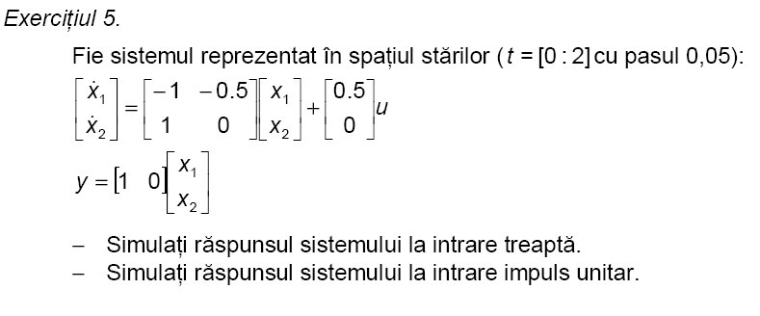
REZOLVARE:
t=[0:0.05:2];
A=[-1 -0.5; 1 0];
B=[0.5;0];
C=[1 0];
D=[0];
step(A,B,C,D,1,t)
impulse (A,B,C,D,1,t)

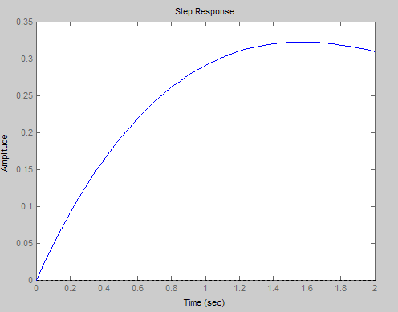
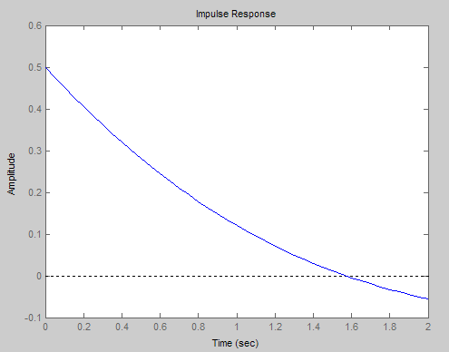
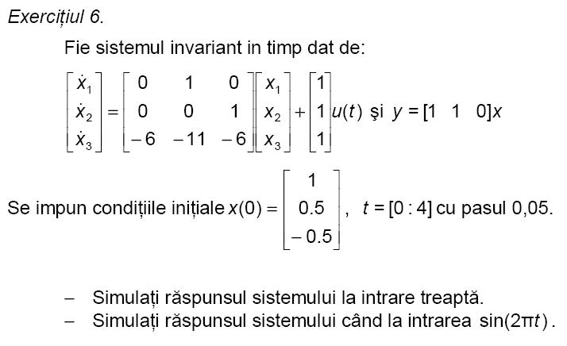
REZOLVARE:
t=[0:0.05:4];
A=[0 1 0;0 0 1;-6 -11 -6];
B=[1;1;1];
C=[1 1 0];
D=[0];
xo=[1;0.5;-0.5];
G=ss2tf(A,B,C,D,1)
sys=ss(A,B,C,D)
step(sys,1,t,xo)
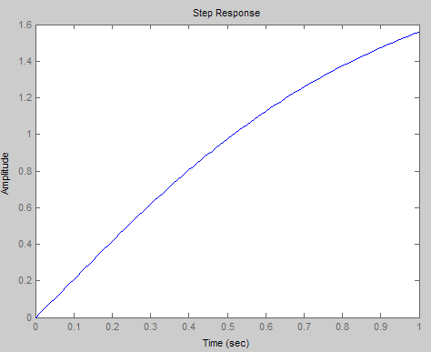

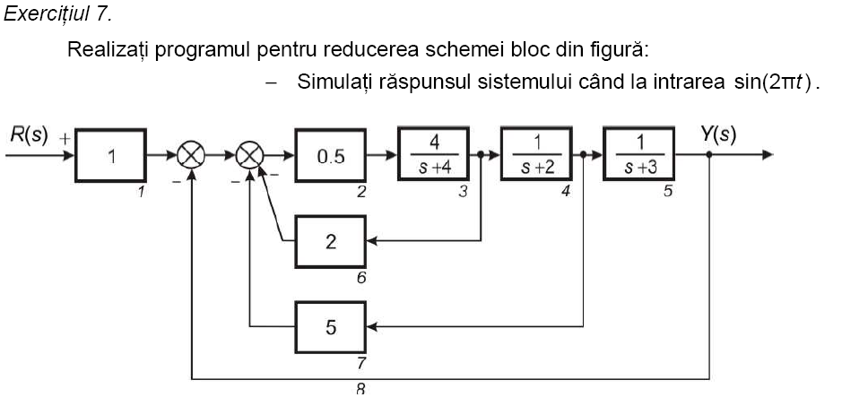
REZOLVARE:
n1=[1]; d1=[1];
n2=[0.5]; d2=[1];
n3=[4]; d3=[1 4];
n4=[1]; d4=[1 2];
n5=[1]; d5=[1 3];
n6=[2]; d6=[1];
n7=[5]; d7=[1];
n8=[1]; d8=[1];
nblocks=8;

q=[1 0 0 0 0 ;
2 1 -6 -7 -8;
3 2 0 0 0;
4 3 0 0 0;
5 4 0 0 0;
6 3 0 0 0 ;
7 4 0 0 0;
8 5 0 0 0;
];
iu=[1];
iy=[8];
blkbuild;
[A,B,C,D] = connect (a,b,c,d,q,iu,iy)
[num,den] =ss2tf (A,B,C,D,iu)

State model [a,b,c,d] of the block diagram has 8 inputs and 8 outputs.

A = -8.0000 -2.5000 -0.5000
4.0000 -2.0000 0
0 1.0000 -3.0000

B = 0.5000
0
0
C = 0 0 1
D =0
num = 0 0.0000 0.0000 2.0000
den =1.0000 13.0000 56.0000 80.0000

Transfer function:
1.066e-014 s^2 + 7.816e-014 s + 2
---------------------------------
s^3 + 13 s^2 + 56 s + 80
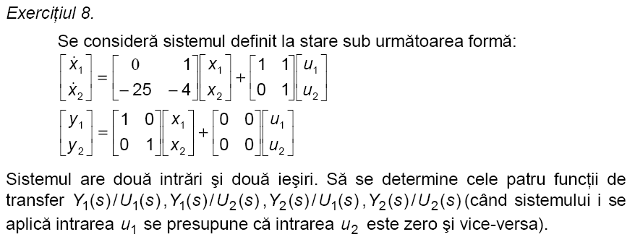
REZOLVARE:
A1=[0 1; -25 -4];
B1=[1; 0];
C1=[1 0];
D1=[0];

A2=[0 1; -25 -4];
B2=[1; 1];
C2=[1 0];
D2=[0];

A3=[0 1; -25 -4];
B3=[1; 0];
C3=[0 1];
D3=[0];

A4=[0 1; -25 -4];
B4=[1; 1];
C4=[0 1];
D4=[0];

[num1,den1]=ss2tf(A1,B1,C1,D1,1);
[num1,den2]=ss2tf(A2,B2,C2,D2,1);
[num2,den1]=ss2tf(A3,B3,C3,D3,1);
[num2,den2]=ss2tf(A4,B4,C4,D4,1);

tf(num1,den1)
tf(num1,den2)
tf(num2,den1)
tf(num2,den2

Transfer function:
s + 5
--------------
s^2 + 4 s + 25

Transfer function:
s + 5
--------------
s^2 + 4 s + 25

Transfer function:
s - 25
--------------
s^2 + 4 s + 25

Transfer function:
s - 25
--------------
s^2 + 4 s + 25
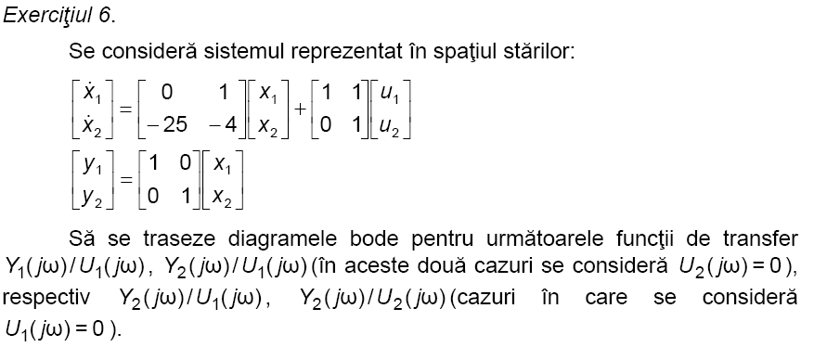
REZOLVARE:
A1=[0 1; -25 -4];
B1=[1; 0];
C1=[1 0];
D1=[0];

A2=[0 1; -25 -4];
B2=[1; 1];
C2=[1 0];
D2=[0];

A3=[0 1; -25 -4];
B3=[1; 0];
C3=[0 1];
D3=[0];

A4=[0 1; -25 -4];
B4=[1; 1];
C4=[0 1];
D4=[0];

bode(A1,B1,C1,D1)
bode(A2,B2,C2,D2)
bode(A3,B3,C3,D3)
bode(A4,B4,C4,D4)

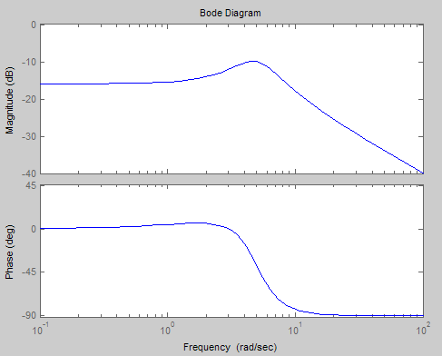

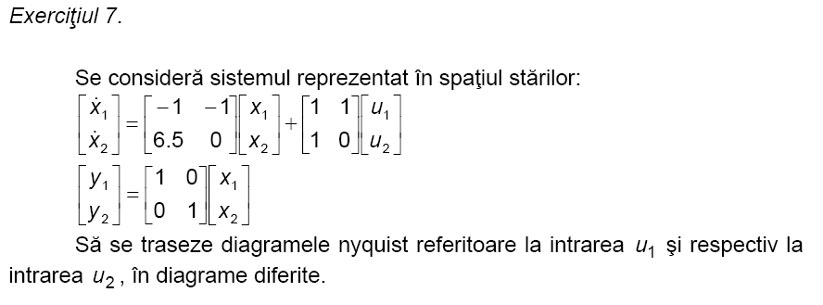
REZOLVARE:
A1=[-1 -1; 6.5 0];
B1=[1; 1];
C1=[1 0];
D1=[0];

A2=[-1 -1; 6.5 0];
B2=[1; 0];
C2=[0 1];
D2=[0];

[num1,den1]=ss2tf(A1,B1,C1,D1,1)
[num2,den2]=ss2tf(A2,B2,C2,D2,1)

nyquist(num1,den1)
Concluzii:
% OBS: Curba nu inceruieste punctul critic (-1,0j) => Sistem stabil

%nyguist(num2,den2)

